** 25 yrs supporting immune systems manage stress, inflammation, optimise resilience ,reduce absenteeism**

**Home About ‘Top Form’ Lifestyle Remedy Epibioenergetics 8 Weeks to A Better You Restore energy Stress & inflammation Weight & Fitness Prevention or cure Employee wellbeing People say Control Life store Contact Blogg Media.**

***NOURISHINGBOX* EMPL0YEE + FAMILY WELLBEING & RESILIENCE**

**ENSURE YOUR COMPANY IS *‘A COMPANY OF CHOICE’* – WITH EMPLOYEE WELLBEING AS A CORE VALUE.**

**THE HEALTH OF YOUR COLLEAGUES DEPENDS ON THEIR CAPACITY TO COPE WITH THE DEMANDS OF THE 21ST CENTURY.**

**STRESS - DEADLY LINGERING INFLAMMATION - CELL TOXICITY UP 500% 2008 - 2018**

**Mental health is the most common cause of absenteeism – 50% cause of turnover.**

**79% surge in employee mental health enquiries.**

**Mental health is the fastest growing demand on medical resources.**

** **

**STRESS – THE MODERN DISEASE – THE BIGGEST KILLER OF ALL.**

**Stress linked inflammation is the underlying cause of 90% of all chronic disease – 3 out of 5 people die from.**

**Stress releases chemicals that increase inflammation in the body and the brain.**

**Stress creates a state of emergency burning up vital nutritional resources.**

**Prolonged stress has devastating consequences for health and relationships – home and work**

**PREVENTION IS BETTER THAN CURE.**

**Your nutritional status – that drives the performance of your immune system**

**- determines, to a substantial extent, your capacity to adapt and maintain health.**

Modern science has discovered that virtually all personal health problems arise from various dysfunctions of the immune system. It is the root-cause, foundational determiner of everything we might come to include inside a personalized definition of health and wellness.

We have been designed by nature to have key bacteria and nutrition every day. Every 72 hours we replace the entire cellular lining of our gut and every day billions of cells wear out and need to be replaced. We have changed our environment, water quality and food chain to such a degree that we are depriving our bodies of vital nutrients.

It is not feasible to obtain all the nutrition we need from today’s diet and global food chain. It is vital to supplement your diet and ensure your gut is healthy and efficiently ingests and absorbs the nutrients you need. The World Health Authority states a balanced diet today does not provide sufficient vitamins. Experts agree today we need 9 portions of fruit and vegatables a day not the recommended 5 to cope with our demanding lifestyle

***”*Your genes interact with your environment (everything you eat, drink and breath) to create you. If you have good nutrition the result is that you have the capacity to adapt to the stresses of life. That's health. If your total environment load exceeds your genetic capacity to adapt, you may develop disease’’ - Patrick Holford - Founder of the Institute for Optimum Nutrition.**

|  |
| --- |
|  |
|  |

**Stress and inflammation are the underlying driver of chronic disease.**

Coping with the demands of our hectic lifestyle are leaving more of us feeling stressed, tired and a declining lack of mental and physical energy. Stress creates a state of emergency within your cellular system releasing chemicals that increase inflammation including the brain. Stress takes the blood flow to the gut reducing the effectiveness of the immune system. Stress also ‘burns up’ vital nutritional resources needed to nourish all the key functions of the mind, body and immune system. In order to have the capacity to adapt to the stresses of life this deficiency – our ‘gap in nutrition’ – needs to be replenished.

Harvard states three out of five people around the world die from a disease linked to inflammation and too much prolonged stress creates ‘chronic stress’, which can have devastating consequences for heath and relationships.

Stress overload contributes to blood pressure, headaches, stomach problems, heart disease, strokes. Stress overload can contribute to emotional problems such as anxiety, panic attacks, fear, anger, fatigue. Science has proven that chronic, low-grade lingering inflammation, which most of us are unaware of, can turn into a silent killer. The US Government, Centers for Disease Control, states 90% of illness and disease relates to stress and inflammation. Harvard and Stanford University Medical Schools, Yale and others support this view.

Recently a well known doctor on an international webinar for employee wellbeing was talking about the main health risks today, emphasising how much greater risk they are than Covid and the importance of nutrition and diet. A main slide stated;  ' Inflammation is the underlying consequence and driver of all chronic disease' - 'Stress releases chemicals that increase the amount of inflammation in the body'. *Inflammation – the ‘silent destroyer’.*

*‘Most people are walking round vertically ill’****Patrick Holford Founder of the Institute for Optimum Nutrition.***

**Could chronic issues and obesity be related to toxin overload which inflames the body?**

The US Environmental Protection Agency reports 250lbs of chemicals, per person, per day are imported into USA. In 2008, Americans and Europeans had an average of 10 toxins per cell. By 2018 this increased to 500 toxins per cell. We have 50 trillion cells. 15 years ago we averaged 1-2 wireless devices at home. Now we have over 10. Toxic free radicals ( invading scavengers) are like corrosive rust on a car, destroying tissue, creating disease and accelerate ageing.

The World Health Organisation reported in 2019, 24% of global deaths were due to environmental toxins. Newcastle University study states the average person eats one plastic credit card a week – 5000 microplastics. Multiple studies suggest heavy metals such as lead and mercury float in our pipeline of ‘dead’ drinking water.

*‘The best way to detoxify is to stop putting toxic things into the body and depend on its own mechanisms’* ***– Andrew Weil MD, Auth. 8 weeks to Optimum Health and founder of the Center for Integrative Medicine***

80% of your immune system and 95% of your cells reside in your gut. Digestion uses up 60% – 80% of your energy. The importance of a well functioning digestive system cannot be over stressed. The everyday exposure to toxins in our food, air and water are overwhelming our liver’s detox processes and digestive system.

This overload creates a backlog of stored toxins that create body wide symptoms. The accumulation of toxic exposures directly congests the gut and this imbalance affects our digestive system, wellbeing and resilience. 99% of the time, the immune system’s job is to switch off adverse reaction to food and toxins. *8 Weeks to A Better You*

*‘’Germs seek their natural habitat – diseased tissue – rather than being the cause of diseased tissue’’.* ***Antoine Bechamp. French Biological Scientist***

**We do not ingest as much nutrition as we think.**

The COVID challenges of new working practices means supporting the wellbeing and resilience and immune capacity of your team is even more important. It is imperative to teach and encourage them to replenish their lifestyle ‘gap in nutrition’.

This ‘gap’ is exacerbated by the fact there is 40% less available nutrition from today’s global food chain, intensive farming, processed food, plus reduced absorption of nutrition due to our polluted environment. 75% of people in the Western World are dehydrated. Both congestion of the gut and dehydration restricts your cells’ ability to absorb and utilise

nutrients, remove toxins that can inflame the body, increases absorption of calories and storage of fat.

Most people are deficient in 8 out of the 13 key nutrients – our ‘gap in nutrition’. Science says disease can be caused by the long term deficiency of only a single vitamin or mineral. .  *8 Weeks to A Better You*

"A vitamin is a substance that makes you ill – if you don’t eat it."   
**Albert von Szent-Gyorgy, 1893 – 1988. Nobel Prize Physiologist.**

**Congestion of the gut restricts absorption and utilisation of nutrients, removal of toxins that inflame the body, increases absorption of calories plus the storage of fat.**

*‘All diseases begin in the gut’.* ***Hippocrates, 460 – 370BC***

‘You are what you eat’ but there is more to it than that. ‘You are what you absorb from what you eat’. One in five people suffer from some degree with Irritable Bowel Syndrome (IBS) including bloated stomach, overweight, digestive problems and as a result a lack of energy and wellbeing.

Inevitably the 21st century lifestyle of convenience foods, antibiotics, drugs, and steroids, an increasingly polluted environment, electromagnetic radiation from mobiles, computers etc contribute to the accumulated build up of toxins which block the lining of the gut, destroy good bacteria, all contributing to congestion of the gut and exposure to free radicals (scavengers).

Toxic free radicals ( invading scavengers) cause disease and accelerate ageing. They enter the bloodstream causing chemical imbalance across our trillions of cells – all resulting in a compromised immune system.  *8 Weeks to A Better You*

Everything passes through your gut. This congestion not only restricts the efficient ingestion and processing of vital nutrition but it increases absorption of calories, plus storage of fat and toxins. Obesity is a fast growing, major health issue today. *Congestion of the gut*

The importance of sufficient nutritional resource to support our mental and physical wellbeing to have the capacity to adapt to the stresses of life is supported by the Mental Health Foundation, Mind charity and Patrick Holford Founder of the Institute for Optimum Nutrition.

*‘We carry our future health in our gut pretty much from birth. Exhaustion ,moodiness, depression, bloating, twenty-first-century-itis is a response to our polluted, urbanized, speeded up world.’* ***Patrick* Holford – Founder of the Institute for Optimum Nutrition.**

**Hydration and oxygenation – your team’s health and vitality depend on it.**

**Dehydration restricts your cells’ ability to absorb and utilize nutrients, remove toxins that can inflame the body, prevent disease, increases absorption of calories and storage of fat.**

*‘’ Water is life’s matter and matrix, mother and medium. There is no life without water’’.* ***Albert Szent – Gyorgy. Nobel Prize winner.***

**We are 65% ‘water intelligent beings’.** The body of a 70 kg man contains about 42 litres of water. Forming a matrix that connects with your 50 trillion cells across the body. We need to drink unpolluted, ‘spring like’ water, enabling the body to hydrate and oxygenate our cells effectively.

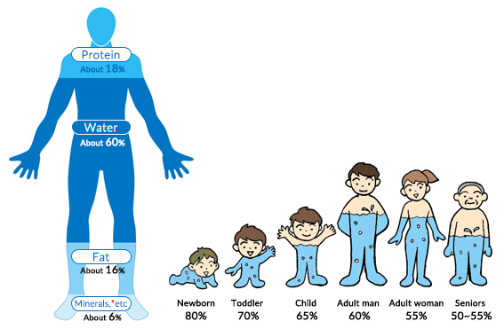

**Hydration of the cells is important for your team’s resilience - 90% of all our biological energy comes from oxygen.**

Most people in the Western World are dehydrated. Often when you feel hungry your body is actually asking for water – clean, energised water, as in its natural environment.

Water is the universal medium for all biological activity and the molecular solute in which all chemicals are dissolved and circulated to our cells. Science says the electronic structure of a molecule or crystal implies essentially its chemical properties.

Our cells are 99% structured water. The functional language of our 50 trillion interconnected cells is electromagnetic. The body is a ‘water battery’.

Oxygen and nutrition, that nourish the performance of our life generating cells, are converted into energy and carried in the molecular structure of water. A drop of water has billions of molecules.

When water flows in and out of the cells they are hydrated with increased oxygen and energy. This enables our cells to generate our energy and resilience, improve absorption and utilization of nutrients to support our immune system. This continuous electromagnetic flow of energy exchange increases cellular detoxing, removing toxins, which in turn reduces inflammation, decreases absorption of calories and storage of fat.

*‘’Water is the life – blood of the earth. When water is healthy it has a complex structure that enables it to communicate information, carry energy, nutrients and healing, to self cleanse and discharge wastes’’.* ***Viktor Schauberger. Naturalist, philosopher, inventor and experimentor.***

Water in it’s natural environment absorbs the sun’s infrared energy. It uses this energy to convert the molecules in bulk water into ‘organised’ or ‘structured’ or ‘hexagonal’ energised water. The vortex movement of water in rivers and streams also energises hexagonal molecular structured water.

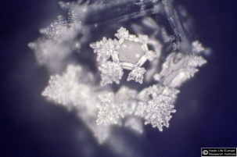 

Plain tap water Same water energised/encoded by Better by Nature

*These photographs show the comparison between plain water and the same water encoded with energy signature ingredients. They capture the structure of the water at the moment of freezing – the 4th phase of water - through high speed photography. Taken by the Hado Life team of Dr Masaru Emoto, an internationally renowned Japanese researcher and Doctor of Alternative Medicine and author of the New York Times best selling The Hidden Messages in Water, the True Power of Water and The Secret Life of Water.*

Chemistry Nobel Prize winner Peter Agre discovered the ‘Aquaporin’ – the minute water channel into the cell, whereby only one water molecule can enter at a time. Smaller hexagonal molecule clusters reduce much easier to single molecules, enabling entry into the Aquaporin. It is this molecular structure and order that enables saturation of our cells – ‘feeding’ - with hydration, oxygen, energy, nutrients, all nurturing the immune system.

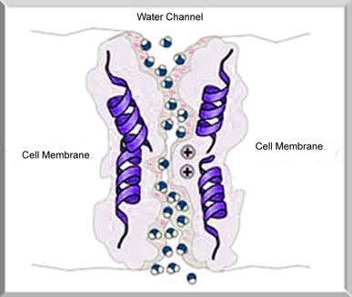

Molecules in ‘living’ healthy structured water are smaller, cluster and move together in hexagonal shape, carrying energy, nutrients and information. These molecules are bioavailable for entry into the minute ‘Aquaporin’ releasing oxygen and nutrients into the cells.

Why do plants look so vibrant after a rain, but when they are watered from a hose pipe, it just isn’t the same? The answer is in the molecular structure of ‘living’ rainwater. The water in rain, rivers, and springs is structured with hexagonal molecules - ‘living energised water’ as nature designed our cells to be hydrated and nourished.

Urbanized tap and bottled water lays ‘dead’ in the pipes and dormant in plastic bottles on shelves. The molecular structure of ‘dead water’ is larger, stretched, distorted and not energized like oxygenated spring water. ‘Dead water’ structure makes it less bio - available to enter the minute ‘Aquaporin’ entry point of cells to hydrate and oxygenate. Like trying to post a parcel through the letterbox.

This leaves our cells dehydrated, lacking oxygen, energy and nourishment to carry out their function and support the immune system. Like a limp flower needing water. Doctors surgeries are full of people with ‘TATT’ – tired all the time syndrome – 21st century – itis.

**The effectiveness of your immune system depends on the oxygen and ‘information’ it receives from the water molecules you drink.**

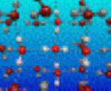

Your water molecules carry the notes for the sheet of music, your cells are the orchestra and your immune system the conductor.

Your chief immune system cells monitor and deal with what is good and bad for the body. The coherent speed and efficiency of your cellular function determines your vitality and resilience, how easily your immune system identifies and eliminates toxins and disease.

Your capacity for life starts with *‘information’* – the notes of music - that dictate – the music your cells play – that determines their ability to generate and drive your energy. ‘*Information’* and energy control your biology.

Toxic energy ‘*information’* signatures from free radical (scavengers), destabilize – distort the music - destabilising the coherence of your cell to cell communication. This impairs the ability to orchestrate and maintain good health and accelerates the ageing process – creating DISharmony and DISease. Over 90% of the time, the immune system’s job is to switch off the adverse reaction to food and toxins. Toxins in our cells increased 500% from 2008 – 2018.

The capacity to live a long and healthy life depends on the degree of coherence of your cell to cell communication system to maintain harmony.

Hence the saying ‘you are what you eat’- the quality of ‘information’ carried by your water molecules - but realistically ‘you are what you absorb from what you eat’ - a healthy gut combined with structured ‘living’ water - which determine your level of wellbeing.

*Like an electrical adaptor for your computer, the human body has to plug in through the water molecule to access the energy that is available. When you are well hydrated you have access to all the energy of the universe, which is infinite…That’s probably enough of a reason to stay hydrated.* ***Dr Zach Bush***

It is a challenge for the majority of people to get access to healthy ‘spring like’ living water or pay for expensive systems that can artificially create structured water. Hexagonal water can be created in your home by vortexing the water and using crystals that hold electromagnetic energy. This creates water that hydrates like a fresh mountain stream.

The good news is that we do not need to drink the stated 2.5 litres, 8 glasses a day of polluted ‘dead’ bulk water. A Mediterranean style, whole food, plant based diet provides much of the structured living water we need from fruit, vegetables and plants. Regular quality water is more important than quantity.

In common, the lifestyles of the seven small blue zones in the world, with the largest percentage of the population living to 100, with mobile and alert lives, include regular excercise, healthy plant based diet and normal weight.

Increasingly more people are beginning to realise what we are doing to the planet, we are duplicating inside our bodies. Today’s standard of polluted bulk water is simply not acceptable.

**Oxygenation defeats viruses.**

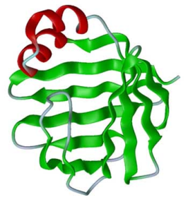

**75% of the Western World are dehydrated** because they drink polluted tap and dormant, plastic bottled water, with a 21st century lifestyle diet. American life expectancy is in decline.

Dr Otto Warburg, 1931 Nobel Prize winner in Physiology and Medicine discovered a cell deprived of 35% required oxygen levels for 48 hours or more is likely to become cancerous. He proved that viruses cannot proliferate or exist in an environment with high levels of oxygen. Viruses are *anaerobic,* meaning they occur and thrive in the absence of oxygen. Every one of us has cancer cells seeking a low-oxygen – dehydrated - environment in which they can multiply into full-blown disease.

*‘’Germs seek their natural habitat – diseased tissue – rather than being the cause of diseased tissue’’.* ***Antoine Bechamp. French Biological Scientist.***

A growing number of medical experts, outside mainstream medicine, now understand cancer is a metabolic disease and the best way to defeat cancer and other chronic disease is to nourish the immune system through **diet, hydration and lifestyle** – *working in harmony with your body and nature.*

*‘The best way to detoxify is to stop putting toxic things into the body and depend upon its own mechanisms’*  - **Andrew Weil MD, Auth. 8 Weeks to Optimum Health and founder of the Center for Integrative Medicine**.

**How does the body get oxygen from water?**

The water we drink is **absorbed by the intestines, and circulated throughout the body in the form of body fluids such as blood**. These perform various functions that keep us alive. They deliver oxygen and nutrients to the cells, and take away waste materials, which are then eliminated with urination.

### The flow of body fluids

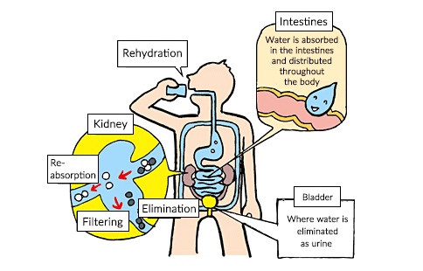

**The functions of body fluids**

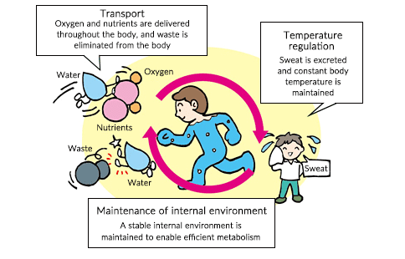

**Help your team adapt to the stresses of life – reduce the cost of absenteeism.**



Science says much of your body replaces itself every 8 weeks. Better by Nature’s ‘8 weeks to a better you’ course coaches a simple pathway, introducing important nutritional support to your body’s innate healing process, improving and maintaining the capacity and ability to cope better.

An appreciated, healthy, vitalised team feeling on ‘top form’ is more creative,

productive and motivated leading to reduced absenteeism and turnover, improved teamwork, increased job satisfaction and improved relationships at work and home.

When employees feel ‘included and connected’- appreciated, job performance increases, sick days are reduced, turnover drops and employee satisfaction, loyalty and ‘talent attracting’ score increase. The *25%* of employers that have a wellbeing programme report these improvements.

On average in the UK absenteeism costs £554 a year per employee and £1bn a day including turnover. Burn out costs $1 trillion – stress $300bn per annum globally. The modern workforce is in a critical state and the health and wellbeing of employees is suffering.

Microsoft reports 41% of the global workforce are considering quitting their jobs. Recent Gallup research reports 87% of the world’s workers feel disengaged and unrecognised. In addition they are suffering increase in obesity and psychological health. We have created overwhelmed employees typically spending 70% of their time in stress.Today 83% of 18 – 24 year olds want to run their own business.

**Enable your team to experience restored energy and resilience - plus a welcome cost of living perk for all their families.**

Talk to us about supporting employee wellbeing as a core value – by introducing *NourishingBox* self funding, deductable*, Employee + Family Wellbeing & Resilience.*

*NourishingBox -* provides your own branded easy to use, self administering webstore. Employees and their families have seamless access to over 100 ‘look better - feel better’ products – health and energy drinks, immune health, nutrition, bee products, sports and weight management, skincare, personal care, essential oils - providing all the nutritional and

personal care support they need, at 50% discount. Essential, effective bio available organic nutrition – as nature intended - is not cheap.

*‘’The human body heals itself and nutrition provides the resources to accomplish the task’’****Roger Williams Ph.D. Nutrition Against Disease.***

*NourishingBox* gift vouchers enhance your community ‘*feel good factor’* by creating a recognition/birthday/family event/ *Reward* *Scheme*. Set up a *Fastbreak Energy Bar.*  4 in 5 employees prefer benefits, in a better place to work, to salary increase.

All employees and their families qualify for complementary benefit of Better by Nature’s ‘8 Weeks to A Better You’ 4 part course (£97) and a free copy of our ‘Your Health is Your Wealth EBook.

All products are backed by the indemnity and money back guarantee of a global, family run, multi billion, debt free, market leading, sustainable carbon neutral company. Vertically integrated, controlling every process from plant to product to customer,innovatively combining science with nature for over 40 years, across 160 countries.

**Restore your team’s energy, be on ‘top form’: – help stressed colleagues avoid burn out, nourish and safeguard a healthy retirement, deter chronic disease and build a legacy of health for their family. *Employee + Family Wellbeing & Resilience.***

**email:** [**support@nourishingbox.com**](mailto:support@nourishingbox.com) **for proposal with schedule of benefits.**

**8 Weeks to A Better Team**

**Experiencing restored energy, feeling on ‘top form’, with the capacity to adapt to our hectic, stressful 21st century lifestyle.**

– helping stressed colleagues avoid burn out, nourish and safeguard a healthy retirement, deter chronic disease and build a legacy of health for their family.

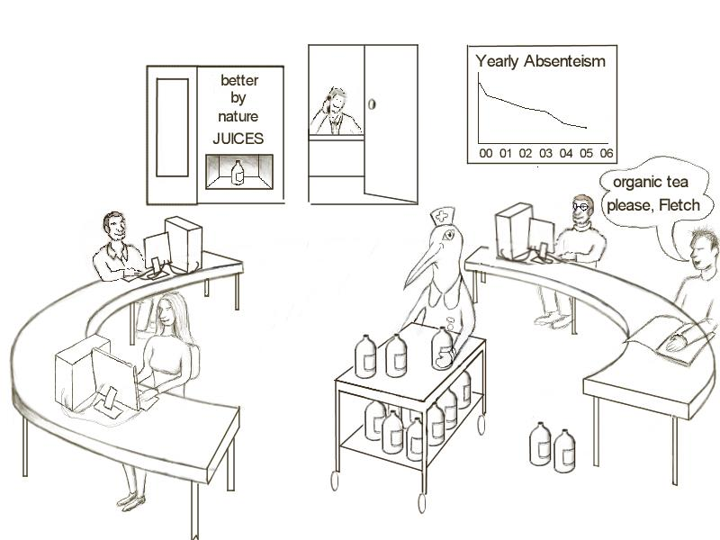

**Lifestyle:** There are seven known small blue zones in the world, including US and Japan. They have the largest percentage of population that live to 100 years, live 12 – 14 years longer than the average American – with declining life expectancy - and enjoy healthy, mobile, mind alert lives. In common, their lifestyle includes regular exercise, healthy plant based diet, normal weight.

All these lifestyle factors interrelate, creating both a cumulative and synergistic benefit enabling you to improve many elements of your wellbeing.

 

**Disease:** Viruses cannot proliferate or exist in an environment with high levels of oxygen. Viruses are *anaerobic,* meaning they occur and thrive in the absence of oxygen. Dr Otto Warburg, Nobel Prize winner in Physiology or Medicine discovered a cell, deprived of 35% required oxygen levels for 48 hours or more, is likely to become cancerous. Every one of us has cancer cells, seeking a low-oxygen environment, in which they can multiply into full-blown disease.

*‘’Germs seek their natural habitat – diseased tissue – rather than being the cause of diseased tissue’’.* ***Antoine Bechamp. French Biological Scientist.***

A growing number of medical experts, outside mainstream medicine, now understand cancer is a metabolic disease and the best way to defeat cancer and other chronic disease is to nourish the immune system through **diet, hydration and lifestyle** – *working in harmony with your body and nature.*

**Good news:** Science says much of your body replaces itself every 8 weeks.

We have been designed by nature to have, each day, key bacteria and nutrition. Every 72 hours we replace the entire cellular lining of our gut and every day billions of cells wear out and are replaced. We have changed our environment, water quality and food chain to such a degree that our bodies are deprived of vital nutrients plus restricted ability to absorb them. Stress then burns up copious amounts of our nutritional resource.

By introducing important nutritional support to nourish your body’s innate healing process, throughout this vital 8 week period, your body and its immune system are better supported to protect against illness and establish a greater sense of wellbeing, at a pace that is totally compatible with your body’s natural cycle of renewal.



All our products carry an unconditional 60 day (8 weeks) money back guarantee to encourage you to harness and benefit from nature’s ‘8 weeks to a better you’ cycle of renewal – *working in harmony with your body and nature.*

*‘The best way to detoxify is to stop putting toxic things into the body and depend on its own mechanisms’ –* ***Andrew Weil MD, Auth. 8 weeks to Optimum Health and founder of the Center for Integrative Medicine***

Wherever you are on the ‘health scale’, as a first step we recommend, Aloe Vera, organic and pure taken from the inner leaf - as nature intended - for optimum bioavailability, as a first step to nourish your immune and digestive systems – a healthy whole food, hydrating plant based, sugar free diet, exercise and 2 litres of ‘spring like living water’ a day being a given! *Choose your Aloe Vera – as nature intended.*  ***Store:*** [***www.nourishingbox.com***](http://www.nourishingbox.com)



Aloe Vera is nature’s perfect ‘ value add & partner product’:

1. 11 proven anti-inflammatory benefits.
2. Nourishes a healthy digestion with natural cleansing abilities enabling more efficient absorption of nutrients and better value from the food budget.
3. Promotes a healthy immune system with 75 vitamins, minerals, amino acids and unique polysaccharides.
4. Helps maintain natural energy and vitality levels. Revered for glowing skin, hair and nails.
5. Aloe Vera is 99% structured plant water. This hydrating structure of stabilised inner leaf gel, optimizes bioavailability to access the cells minute point of entry.

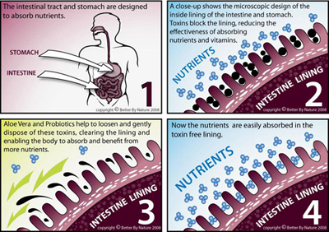

Doctors spend less than 7 hours in their academic career learning about nutrition and environmental toxins – despite the clear connection between gut and liver imbalances and chronic symptoms. We are duplicating inside our bodies what we are doing to the planet.

*‘If Aloe Vera were to be discovered today, and it’s remarkable healing properties investigated, it would be hailed as the ‘wonder drug’ of this century’.* ***Ivan Danhoff Ph. D.,M.D.***

**KNOWLEDGE ENABLES WELLBEING**

*‘The doctor of the future will give no medication but will interest his patients in the care  
 of the human frame, diet and the cause and prevention of disease’****, - Thomas Edison***

For 25 years Better by Nature has been helping people support their immune system holistically, to manage stress, improve wellbeing and be on ‘top form’– *working in harmony with your body and nature.*

*Your Health Is Your Wealth*E-Book provides knowledge for the average person, to better understand how to achieve optimum wellbeing, cope better and adapt to today’s hectic lifestyle. It provides an important insight into how our mind and body interacts with the environment, to create good health and wellbeing or poor health, and how you can simply nourish and take control of your wellbeing***.***



**8 Weeks to A Better You – course - *intranet, group, team, 1: 1.***

**Modules:** <https://eightweekstoabetteryou.mastermind.com/masterminds/32609>

* [The good news - learn how you could take control of your health and wellbeing.](https://beontopform.mastermind.com/masterminds/32609#module-39807)
* [Avoid stress linked inflammation - sidestep chronic disease](https://beontopform.mastermind.com/masterminds/32609#module-39808).
* [Create and maintain a healthy lifestyle - prevention better than cure](https://beontopform.mastermind.com/masterminds/32609#module-39809).
* [Feel, fitter, younger, healthier be on 'top form' - experience optimum wellbeing](https://beontopform.mastermind.com/masterminds/32609#module-39810).

. This information is also adaptable for company intranets as part of our deductable *Employee + Family Wellbeing & Resilience*

*‘Avoiding the danger of stress linked inflammation by harnessing the dynamics of multiple synergy to nourish your mind, body and immune system – nature’s fastest and easiest way to restore energy and be on ‘top form’ –* ***Michael Riley. Founder - Better by Nature.***

**PREVENTION IS BETTER THAN CURE**

*‘’ He who has health has hope, and he who has hope has everything’’* ***– an Arabian proverb.***

Restore your team’s energy, be on ‘top form’: – help stressed colleagues avoid burn out, nourish and safeguard a healthy retirement, deter chronic disease and build a legacy of health for their family. *Employee + Family Wellbeing & Resilience*

email: [support@nourishingbox.com](mailto:support@nourishingbox.com) for proposal with schedule of benefits.

*We strongly advise that a qualified medical practitioner is consulted for diagnosis and treatment of medical conditions. Our products are in no way to be considered a substitute for this.*