** 25 yrs supporting immune systems manage stress, inflammation, optimise resilience, reduce absenteeism**

**Home About Be on top form Stress linked inflammation Restore energy Employee wellbeing**

**People say Control Life store Blog Contact/ Media**

***NOURISHINGBOX* EMPL0YEE + FAMILY WELLBEING & RESILIENCE**

**THE HEALTH OF YOUR COLLEAGUES TO BE ON TOP FORM, DEPENDS ON THEIR CAPACITY TO COPE WITH THE DEMANDS OF THE 21ST CENTURY.**

**STRESS - DEADLY LINGERING INFLAMMATION - CELL TOXICITY UP 500% 2008 - 2018**

**ENSURE YOUR COMPANY IS *‘A COMPANY OF CHOICE’* – WITH EMPLOYEE WELLBEING AS A CORE VALUE.**

**Microsoft reports 64% of employees say they struggle with the time and energy to do their job and 41% are considering quitting their job.**

**Mental health is the most common cause of absenteeism – 50% cause of turnover.**

**79% surge in employee mental health enquiries.**

**Mental health is the fastest growing demand on medical resources.**

** **

**STRESS – THE MODERN DISEASE – THE BIGGEST KILLER OF ALL.**

**Stress linked inflammation is the underlying cause of 90% of all chronic disease – 3 out of 5 people die from.**

**Stress releases chemicals that increase inflammation in the body and the brain.**

**Stress creates a state of emergency burning up vital nutritional resources, needed for vital functions of the mind, body and immune system.**

**Prolonged stress has devastating consequences for health and relationships – home and work.**

**THE EMPLOYMENT PANDEMIC**

**Wellness is not a ’nice to have’ or squeezing in a weekend yoga class. It is a key building block of sustained performance.**

We have today created overwhelmed employees, typically spending 70% of their time in stress. BetterUp Labs research across companies and industries over an 11 month period, found those 55% who languish experience heightened stress and physical and mental exhaustion, decreasing their sense of wellbeing.

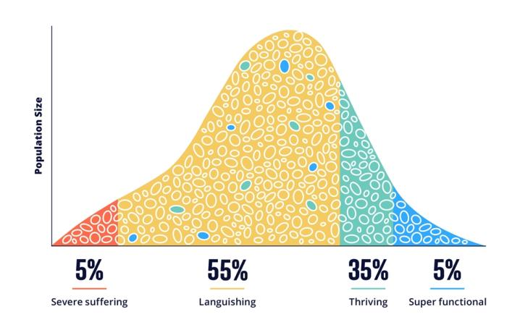

A study released by Qualtrics found that 54.4% of employees reported their mental health as something less than healthy.

Recent Gallup research reports 87% of the world’s workers, 62/68% USA, feel disengaged and unrecognised. In addition they are suffering increase in obesity and psychological health.Deloite’s finding is 46% have no interest driven motivation for their work and only 14% have high interest and motivation.

Microsoft reports 41% of the global workforce are considering quitting their jobs and 64% say they struggle with the time and energy to do their jobs. These people are 3.5 times more likely to struggle with innovation and strategic thinking.

On average in the UK absenteeism costs £554 a year per employee and £1bn a day including turnover. Burn out costs $1 trillion – stress $300bn per annum globally. The modern workforce is in a critical state, with the health and wellbeing of employees suffering.

Today 83% of 18 – 24 year olds want to run their own business. So many have witnessed the working life of their parents. We are heading for a ‘resignation revolution’, an escalating mental health crisis, plus the additional stressors of increased pace of change due to technology such as AI.

When employees feel ‘included and connected’- appreciated, job performance increases, sick days are reduced, turnover drops and employee satisfaction, loyalty and ‘talent attracting’ score increase. The *25%* of employers that have a wellbeing programme report these improvements. The environment in smaller companies, where everybody knows everyone, is easier to foster engagement than just being a number in a large organisation.

Economic uncertainty is increasing pressure on companies to perform. As expectations between employees and employers continue to shift, productivity, performance and adaptability are more critical in the workplace than ever before.

According to further research employees with the best wellbeing had 56% fewer missed days at work and were five times more likely to be rated top performers. Additionally employees who prioritise their wellbeing experience lower levels of burn out and are more resilient in the face of stressors. Wellbeing remains key to overcoming these challenges, unlocking better outcomes and enabling employees to experience restored energy, enjoying being on top form.

**The key slice of the wellbeing cake**

Wellbeing is the holistic equilibrium of our (A) emotional, (B) social, (C) spiritual, (D) physical and (E) intellectual status. The simplest way to measure our state of wellbeing is our resilience. Our resilience is our capacity to cope with and adapt to the stressful demands of our 21st century lifestyle.

Our capacity depends on our nutritional resources which nourish our cells that generate our energy. Optimum resilience is not only the capacity to cope but to generate sufficient energy to maintain and enjoy being on top form – *working in harmony with your body and nature.*

*Be on top form*

Resilience is the icing on the holistic equilibrium cake. Optimum nutrition enables our resilience. It is the first prime and easiest step to take. Most of us are handicapped by our 21st century ‘gap in nutrition’- outlined below.

Each of us have different levels in the vagaries of our A, B, C, D, and E status. That’s life. To deal with any issues to improve our life burns up additional nutritional resources. That makes nourishing our resilience and energy the top priority. Energy supports emotional wellbeing - focusing on the positive, managing negative emotions meeting the demands of modern day life.

Your team deserves to experience and understand optimum wellbeing and resilience. They are worth it. They will thank you. So will their families.

*‘Optimum nutrition is the medicine of the future’ –* ***Dr Linus Pauling. Twice (unshared) Nobel Prize Winner.***

**PREVENTION IS BETTER THAN CURE**

* **1oz of prevention is better than 1lb of cure.**

**Your nutritional status drives the performance of your immune system**

**- which determines your capacity to adapt, maintain health and be on top form.**

Combining modern science with nature has discovered that virtually all personal health problems arise from various dysfunctions of the immune system. It is the root-cause, foundational determiner of everything we might come to include inside a personalized definition of health and wellness.

We have been designed by nature to have key bacteria and nutrition every day. Every 72 hours we replace the entire cellular lining of our gut and each day billions of cells wear out and need to be replaced. We have changed our environment, water quality and food chain to such a degree that we are depriving our bodies of vital nutrients.

It is not feasible to obtain all the nutrition we need from today’s diet and global food chain. It is vital to supplement your diet and ensure your gut is healthy and efficiently ingests and absorbs the nutrients you need. The World Health Authority states a balanced diet today does not provide sufficient vitamins. Experts agree today we need 9 portions of fruit and vegetables a day, not the recommended 5, to cope with our hectic, stressful lifestyle.

***”*Your genes interact with your environment (everything you eat, drink and breath) to create you. If you have good nutrition the result is that you have the capacity to adapt to the stresses of life. That's health. If your total environment load exceeds your genetic capacity to adapt, you may develop disease’’ - Patrick Holford - Founder of the Institute for Optimum Nutrition.**

|  |
| --- |
|  |
|  |

**Stress and inflammation are the underlying driver of chronic disease and contributor to absenteeism.**

Coping with the demands of our hectic lifestyle are leaving more of us feeling stressed, tired and a declining lack of mental and physical energy. Stress creates a state of emergency within your cellular system releasing chemicals that increase inflammation including the brain. Stress takes the blood flow to the gut reducing the effectiveness of the immune system. Stress also ‘burns up’ vital nutritional resources needed to nourish all the key functions of the mind, body and immune system.

In order to have the capacity to adapt to the stresses of life this deficiency – our ‘gap in nutrition’ – needs to be replenished. Harvard states three out of five people around the world die from a disease linked to inflammation and too much prolonged stress creates ‘chronic stress’, which can have devastating consequences for heath and relationships.

Stress overload contributes to blood pressure, headaches, stomach problems, heart disease, strokes. Stress overload can contribute to emotional problems such as anxiety, panic attacks, fear, anger, fatigue. Science has proven that chronic, low-grade lingering inflammation, which most of us are unaware of, can turn into a silent killer. The US Government, Centers for Disease Control, states 90% of illness and disease relates to stress and inflammation. Harvard and Stanford University Medical Schools, Yale and others support this view.

Recently a well known doctor on an international webinar for employee wellbeing was talking about the main health risks today, emphasising how much greater risk they are than Covid and the importance of nutrition and diet. A main slide stated;  ' Inflammation is the underlying consequence and driver of all chronic disease' - 'Stress releases chemicals that increase the amount of inflammation in the body'.

*Stress linked inflammation – the silent destroyer.*

*‘Most people are walking round vertically ill’****Patrick Holford Founder of the Institute for Optimum Nutrition.***

**Our bodies are further inflamed by toxin overload, exacerbating the effects of stress linked inflammation.**

The US Environmental Protection Agency reports 250lbs of chemicals, per person, per day are imported into USA. In 2008, Americans and Europeans had an average of 10 toxins per cell. By 2018 this increased to 500 toxins per cell. We have 50 trillion cells. 15 years ago we averaged 1-2 wireless devices at home. Now we have over 10. Toxic free radicals (invading scavengers) are like corrosive rust on a car, destroying tissue, creating disease and accelerate ageing.

The World Health Organisation reported in 2019, 24% of global deaths were due to environmental toxins. Newcastle University study states the average person eats one plastic credit card a week – 5000 microplastics. Multiple studies suggest heavy metals such as lead and mercury float in our pipeline of ‘dead’ drinking water.

*‘The best way to detoxify is to stop putting toxic things into the body and depend on its own mechanisms’* ***– Andrew Weil MD, Auth. 8 weeks to Optimum Health and founder of the Center for Integrative Medicine***

80% of your immune system and 95% of your cells reside in your gut. Digestion uses up 60% – 80% of your energy. The importance of a well functioning digestive system cannot be over stressed. The everyday exposure to toxins in our food, air and water are overwhelming our liver’s detox processes and digestive system.

This overload creates a backlog of stored toxins that create body wide symptoms. The accumulation of toxic exposure directly congests the gut and this imbalance affects our digestive system, restricting our absorption of nutrients and increasing storage of fat. This all impacts our wellbeing, resilience and being on top form. 99% of the time, the immune system’s job is to switch off adverse reaction to food and toxins.

*Be on top form*

*‘’Germs seek their natural habitat – diseased tissue – rather than being the cause of diseased tissue’’.* ***Antoine Bechamp. French Biological Scientist***

**Congestion of the gut restricts absorption and utilisation of nutrients, removal of toxins that inflame the body, increases absorption of calories plus the storage of fat.**

*‘All diseases begin in the gut’.* ***Hippocrates, 460 – 370BC***

‘You are what you eat’ but there is more to it than that. ‘You are what you absorb from what you eat’. One in five people suffer from some degree with Irritable Bowel Syndrome (IBS) including bloated stomach, overweight, digestive problems and as a result a lack of energy and wellbeing.

Inevitably the 21st century lifestyle of convenience foods, antibiotics, drugs, and steroids, an increasingly polluted environment, electromagnetic radiation from mobiles, computers etc contribute to the accumulated build up of toxins which block the lining of the gut, destroy good bacteria, all contributing to congestion of the gut and exposure to free radicals (scavengers).

Toxic free radicals (invading scavengers) cause disease and accelerate ageing. They enter the bloodstream causing chemical imbalance across our trillions of cells – all resulting in a compromised immune system.

Everything passes through your gut. This congestion not only restricts the efficient ingestion and processing of vital nutrition but it increases absorption of calories, plus storage of fat and toxins. Obesity is a fast growing, major health issue today. *Be on top form*

The importance of sufficient nutritional resource to support our mental and physical wellbeing to have the capacity to adapt to the stresses of life is supported by the Mental Health Foundation, Mind charity and Patrick Holford Founder of the Institute for Optimum Nutrition.

*‘We carry our future health in our gut pretty much from birth. Exhaustion ,moodiness, depression, bloating, twenty-first-century-itis is a response to our polluted, urbanized, speeded up world.’* ***Patrick* Holford – Founder of the Institute for Optimum Nutrition.**

**Our nutritional resources are stretched even further than we assume.**

New working practices, after Covid, plus today’s digitally distributed workforce means it is even more important to support the wellbeing, resilience and immune capacity of your team. It is imperative to teach and encourage them to replenish their lifestyle ‘gap in nutrition’.

This ‘gap’ is exacerbated by the fact there is 40% less available nutrition from today’s global food chain, intensive farming, processed food, plus reduced absorption of nutrition due to our polluted environment. 75% of people in the Western World are dehydrated. Both congestion of the gut and dehydration restricts your cells’ ability to absorb and utilise

nutrients, remove toxins that can inflame the body, increases absorption of calories and storage of fat.

Most people are deficient in 8 out of the 13 key nutrients – our ‘gap in nutrition’. Science says disease can be caused by the long term deficiency of only a single vitamin or mineral. .  *Be on top form*

"A vitamin is a substance that makes you ill – if you don’t eat it."   
**Albert von Szent-Gyorgy, 1893 – 1988. Nobel Prize Physiologist.**

**Hydration and oxygenation – critical for your team’s health, resilience and being on top form.**

**Dehydration restricts our cells’ ability to absorb and utilize nutrients, generate our energy, remove toxins that inflame the body, prevent disease, increases absorption of calories and storage of fat.**

*‘’ Water is life’s matter and matrix, mother and medium. There is no life without water’’.* ***Albert Szent – Gyorgy. Nobel Prize winner.***

**We are 65% ‘water intelligent beings’.** The body of a 70 kg man contains about 42 litres of water. Forming a matrix that connects with your 50 trillion cells across the body. We need to drink unpolluted, structured ‘spring like living water’, enabling the body to hydrate and oxygenate our cells effectively.

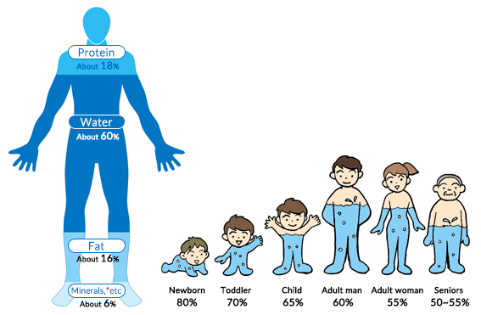

**Hydration of the cells is important for your team’s resilience - 90% of all our biological energy comes from oxygen.**

Most people in the Western World are dehydrated. Often when you feel hungry your body is actually asking for water – clean, energised water, as in its natural environment. Water in its natural form has clusters of smaller molecules, structured water, making them bioavailable to hydrate our cells. ‘Dead’ water lying in pipes and shelves in the supermarket have larger molecules that cannot easily enter your cells. Like trying to post a parcel through a letter box.

**The effectiveness of your immune system depends on the oxygen and ‘information’ it receives from the water molecules you drink.**

Water is the universal medium for all biological activity and the molecular solute in which all chemicals are dissolved and circulated to our cells. Science says the electronic structure of a molecule or crystal implies essentially its chemical properties.

Our cells are 99% structured water. The functional language of our 50 trillion interconnected cells is electromagnetic. The body is a ‘water battery’.

Oxygen and nutrition (food), that nourish the performance of our life generating cells and thereby our immune system, are converted into energy ‘information’ and carried in the molecular structure of water. A drop of water has billions of molecules.

When water flows in and out of the cells they are hydrated with increased oxygen and energy. This enables our cells to generate our energy and resilience, improve absorption and utilization of nutrients to support our immune system. This continuous electromagnetic flow of energy exchange increases cellular detoxing, removing toxins, which in turn reduces inflammation, decreases absorption of calories and storage of fat. Oxygenating our cells enables us to be on top form.

*Hydration and oxygenation*

*‘’Water is the life – blood of the earth. When water is healthy it has a complex structure that enables it to communicate information, carry energy, nutrients and healing, to self cleanse and discharge wastes’’.* ***Viktor Schauberger. Naturalist, philosopher, inventor and experimentor.***

**Help your team adapt to the stresses of life – reduce the cost of absenteeism.**



Science says much of your body replaces itself every 8 weeks. Nature’s cycle of renewal. Better by Nature’s, ‘8 Weeks to A Better You’ programme and ‘Be on top form’ course coaches a simple pathway, introducing important nutritional support to your body’s innate healing process. This also creates the capacity to adapt and cope better, with greater resilience and being on top form – *working in harmony with your body and nature.*

An appreciated, healthy, vitalised team feeling on ‘top form’ is more creative,

productive and motivated, leading to reduced absenteeism and turnover, improved teamwork, increased job satisfaction with improved relationships at work and home.

**Enable your team to experience restored energy, resilience and be on top form - plus a welcome cost of living perk for all their families.**

Talk to us about harnessing employee wellbeing – introducing *NourishingBox* self funding *Employee + Family Wellbeing & Resilience.*

*NourishingBox -* provides your own branded easy to use, self administering webstore. Employees and their families have seamless access to over 100 ‘look better - feel better’ products – health and energy drinks, immune health, nutrition, bee products, sports and weight management, skincare, personal care, essential oils - providing all the nutritional and

personal care support they need, at 50% discount. Essential, effective bio available organic nutrition – as nature intended - is not cheap.

*‘’The human body heals itself and nutrition provides the resources to accomplish the task’’****Roger Williams Ph.D. Nutrition Against Disease.***

*NourishingBox* gift vouchers enhance your community ‘*feel good factor’* by creating a recognition/birthday/family event/ *Reward* *Scheme*. Set up a relaxing *Fastbreak Energy Bar.*  4 in 5 employees prefer benefits, in a better place to work, to salary increase.

All employees and their families qualify for complementary benefit of Better by Nature’s ‘Be on top form’ 4 part course (£97) and a free copy of our ‘Your Health is Your Wealth EBook.

All products are backed by the indemnity and money back guarantee of a global, family run, multi - billion, debt free, market leading, sustainable carbon neutral company. Vertically integrated, controlling every process from plant to product to customer,innovatively combining science with nature for over 40 years, across 160 countries.

**email:**  [support@beontopform.com](mailto:support@beontopform.com)To book a call or for proposal with schedule of benefits.

**8 Weeks to A Better Team**

**Experiencing restored energy, feeling on ‘top form’, with the capacity to adapt to our hectic, stressful 21st century lifestyle.**

– helping stressed colleagues avoid burn out, nourish and safeguard a healthy retirement, deter chronic disease and build a legacy of health for their family.

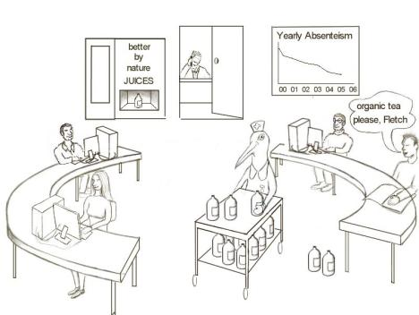

**Some populations live to 100 years while Americans have a declining life expectancy.**

 

**Lifestyle:** There are seven known small blue zones in the world, including US and Japan. They have the largest percentage of population that live to 100 years, live 12 – 14 years longer than the average American – *with declining life expectancy* - and enjoy healthy, mobile, mind alert lives. In common, their lifestyle includes regular exercise, healthy

hydrating plant based diet, normal weight.

*Stress linked inflammation/ 7 steps to a healthy lifestyle*

The good news is all these lifestyle factors interrelate, creating both a cumulative and synergistic benefit. This enables you to improve many elements of your wellbeing, restore energy and be on top form with each positive change you make. – *working in harmony with your body and nature*.

**Oxygenating our cells defeats viruses.**

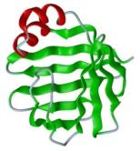

**Disease:** Viruses cannot proliferate or exist in an environment with high levels of oxygen. Viruses are *anaerobic,* meaning they occur and thrive in the absence of oxygen. Dr Otto Warburg, Nobel Prize winner in Physiology or Medicine discovered a cell, deprived of 35% required oxygen levels for 48 hours or more, is likely to become cancerous. Every one of us has cancer cells, seeking a low-oxygen environment, in which they can multiply into full-blown disease.

*‘’Germs seek their natural habitat – diseased tissue – rather than being the cause of diseased tissue’’.* ***Antoine Bechamp. French Biological Scientist***

Hydration critically oxygenates our cells. **7**5% of the Western World are dehydrated because they do not drink enough and the water they do drink is polluted, ‘dead’ tap and dormant, plastic bottled water.

*‘’Water is the life – blood of the earth. When water is healthy it has a complex structure that enables it to communicate information, carry energy, nutrients and healing, to self cleanse and discharge wastes’’.* ***Viktor Schauberger. Naturalist, philosopher, inventor and experimentor.***

A growing number of medical experts, outside mainstream medicine, now understand cancer is a metabolic disease and the best way to defeat cancer and other chronic disease is to nourish the immune system through **diet, hydration and lifestyle** enabling us to be on top form with the capacity to adapt to our hectic, stressful 21st century lifestyle – *working in harmony with your body and nature.*

**Good news:** Science says much of your body replaces itself every 8 weeks.

We have been designed by nature to have, each day, key bacteria and nutrition. Every 72 hours we replace the entire cellular lining of our gut and every day billions of cells wear out and are replaced. We have changed our environment, water quality and food chain to such a degree that our bodies are deprived of vital nutrients plus restricted ability to absorb them. Stress then burns up copious amounts of our nutritional resource.

By introducing important nutritional support to nourish your body’s innate healing process, throughout this vital 8 week period, your body and its immune system are better supported to protect against illness and establish a greater sense of wellbeing, at a pace that is totally compatible with your body’s natural cycle of renewal.

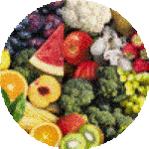

*‘The best way to detoxify is to stop putting toxic things into the body and depend on its own mechanisms’ –* ***Andrew Weil MD, Auth. 8 weeks to Optimum Health and founder of the Center for Integrative Medicine***

**Wherever you are on the ‘health scale’**

As a first step, we recommend Aloe Vera, with 75 nutrients, organic and pure taken from the inner leaf, as nature intended for optimum bioavailability, to support your digestive and immune systems – a healthy whole food, hydrating plant based, sugar free diet, exercise and 2 litres of ‘spring like living water’ a day being a given.

*Choose your Aloe Vera and supplements – as nature intended. Nourishingbox Store*

**

Aloe Vera is nature’s perfect ‘enhancing - partner product’:

1. 11 proven anti-inflammatory benefits.
2. Supports healthy digestion with natural cleansing abilities enabling more efficient absorption of nutrients and better value from the food budget.
3. Promotes a healthy immune system with 75 vitamins, minerals, amino acids and unique polysaccharides.
4. Helps maintain natural energy and vitality levels. Revered for glowing skin, hair and nails.
5. Aloe Vera is 99% structured plant water. This hydrating structure of stabilised inner leaf gel, optimizes bioavailability to access the cells minute point of entry.

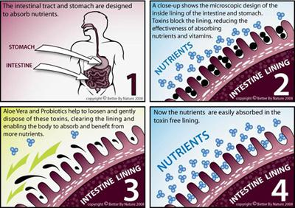

*‘If Aloe Vera were to be discovered today, and it’s remarkable healing properties investigated, it would be hailed as the ‘wonder drug’ of this century’****. Ivan Danhoff Ph. D., M.D.***

All our products carry an unconditional 60 day (8 weeks) money back guarantee to encourage you to harness and benefit from nature’s ‘8 weeks to a better you’ cycle of renewal – *working in harmony with your body and nature*

*Be on top form*  *NourishingBox Store*

*‘Optimum nutrition is the medicine of the future’ –* ***Dr Linus Pauling. Twice (unshared) Nobel Prize Winner.***

**KNOWLEDGE ENABLES WELLBEING**

*‘The doctor of the future will give no medication but will interest his patients in the care  
 of the human frame, diet and the cause and prevention of disease’****, - Thomas Edison***

For 25 years Better by Nature has been helping people support their immune system holistically, to manage stress, improve wellbeing and be on ‘top form’– *working in harmony with your body and nature.*

*Your Health Is Your Wealth*E-Book provides knowledge for the average person, to better understand how to achieve optimum wellbeing, cope better and adapt to today’s hectic lifestyle. It provides an important insight into how our mind and body interacts with the environment, to create good health and wellbeing or poor health, and how you can simply take control of your wellbeing*– working in harmony with your body and nature.*

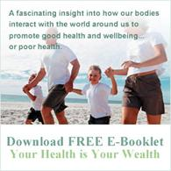

**Be on top form – course - *intranet, group, team, 1: 1.***

**Modules:**

* [The good news - learn how you could take control of your health and wellbeing.](https://beontopform.mastermind.com/masterminds/32609#module-39807)
* [Avoid stress linked inflammation - sidestep chronic disease](https://beontopform.mastermind.com/masterminds/32609#module-39808).
* [Create and maintain a healthy lifestyle - prevention better than cure](https://beontopform.mastermind.com/masterminds/32609#module-39809).
* [Feel, fitter, younger, healthier be on 'top form' - experience optimum wellbeing](https://beontopform.mastermind.com/masterminds/32609#module-39810).

<https://beontopform.mastermind.com/masterminds/32609>

This information is also adaptable for company intranets as part of our self funding *Employee + Family Wellbeing & Resilience*

*‘Avoiding the danger of stress linked inflammation by harnessing the dynamics of multiple synergy to nourish your mind, body and immune system – nature’s fastest and easiest way to restore energy and be on ‘top form’ –* ***Michael Riley. Founder - Better by Nature.***

**PREVENTION IS BETTER THAN CURE**

*‘’ He who has health has hope, and he who has hope has everything’’ – an Arabian proverb.*

To restore energy, be on top of your game, nourish retirement, enhance employee + family wellbeing email [support@beontopform.com](mailto:support@beontopform.com).

*We strongly advise that a qualified medical practitioner is consulted for diagnosis and treatment of medical conditions. Our products are in no way to be considered a substitute for this.*